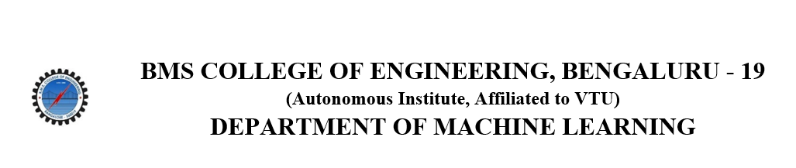
ACTIVITY REPORT
ON
TOWN HALL FOR ACM STUDENTS
- Name of the Club: BMSCE ACM STUDENT CHAPTER
- Name of the Activity: TOWN HALL FOR ACM STUDENTS
- Objectives: The Town Hall for ACM Students, held virtually on April 5th, 2025, brought together ACM student chapter members and faculty from across the country for an enriching interaction with the ACM India Council. The event aimed to foster collaboration, recognize excellence, and offer guidance on how student chapters can thrive and make meaningful contributions to the ACM community.
- Date, Time Venue of the Activity:
EVENT | Town Hall for ACM students
DATE/DAY | Saturday, 5th April 2025
TIME | 2:00 PM to 4:30 PM
VENUE | Virtual event
- Name and details of collaborating agency (if it is collaborative/joint activity): ACM INDIA Council in association with BMSCE ACM Student Chapter.

- Brief summary of the Event:
Opening Remarks (2:00 PM – 2:20 PM):
The session began with warm welcomes from Dr. Yogesh Simmhan and Maria Dsouza Choudhary representing the ACM India Council, followed by opening remarks from Dr. Seemantini K, Faculty Sponsor of BMSCE ACM Student Chapter. Their words highlighted the importance of community, student involvement, and research-led growth in computing.
Awards Recognition (2:20 PM – 2:30 PM):
Dr. Ranga Rajagopal recognized the achievements of various student chapters and lauded their innovative contributions, particularly highlighting chapters that demonstrated exemplary initiative throughout the year.
AMA Session (2:30 PM – 2:50 PM):
A dynamic "Ask Me Anything" segment allowed students to directly interact with ACM leaders including Dr. Ponnurangam Kumaraguru, Dr. Yogesh Simmhan, Maria Dsouza Choudhary, Dr. Ranga Rajagopal, Dr. Geetanjali Kale, Dr. Abhijat Vichare, and Dr. Shourya Roy. Discussions ranged from research careers and project funding to navigating the student chapter ecosystem.
Region-wise Presentations (2:50 PM – 4:00 PM):
Student chapters from all six ACM India regions presented their key activities, challenges, and successes:
- Regions 1 & 2: Showcased vibrant initiatives, workshops, and inter-collegiate collaborations.
- Regions 3 & 4: Emphasized research outreach, inclusivity, and participation in national events.
- Regions 5 & 6: Displayed outstanding student-led events, social impact campaigns, and magazine releases.
Special Sessions:
- Activity-Based Funding (3:10 PM – 3:20 PM) by Dr. Rutvi Shah provided clear guidelines on how student chapters can avail funding by planning impactful activities.
- How to Win Awards? (3:35 PM – 3:45 PM) by Dr. Geetanjali Kale offered actionable insights into what makes a chapter stand out—documenting activities, collaboration, innovation, and community service.

- Outcomes:
Student chapters are encouraged to maintain consistency, community engagement, and alignment with ACM’s core mission.
Collaboration among chapters and proactive planning can lead to national recognition and awards.
Regular documentation and social media presence significantly enhance a chapter’s visibility.
The ACM India Council is highly supportive and open to student-led initiatives that create long-term impact.

- Number of participants:
Number of participants | 125

- Photographs of the event:
